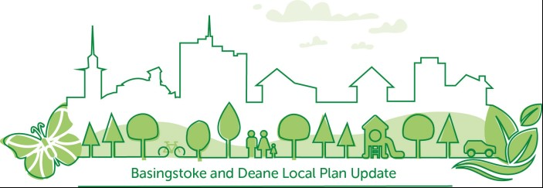

Local Green Space: Site Promotion Form

Please use this form if you wish to promote a site to be considered for designation as Local Green Space through the Local Plan Update. Such spaces must meet the relevant criteria as set out in the National Planning Policy Framework (NPPF) and associated Planning Practice Guidance.

For further information on Local Green Space designation and criteria please read the accompanying Local Green Space Promotion Guidance Note on the Local Plan Update Issues and Option webpage.

Forms (along with a clear map of the site boundary) should be returned by email to local.plan@basingstoke.gov.uk

Forms can also be returned by post to: Planning Policy Team, Basingstoke and Deane Borough Council, Civic Offices, London Road, Basingstoke, Hampshire, RG21 4AH

All forms and maps must be returned by Monday 9 November 2020, in line with the closure of the council’s Local Plan Update Issues and Options Consultation.
Data protection statement:

Your personal data will be used by the Planning Policy Team to process your submission and to contact you, if necessary. We are required to undertake an assessment of the land identified in your submission and this assessment, comprising site specific information you have provided, will be made publicly available on the council’s website. If the submission is made by an individual, your personal details will not be published without your prior consent. Any person submitting a site may withdraw their submission at any time by giving notice in writing to the council either by email or post at the addresses given above.

Basingstoke and Deane Borough council is the data controller for any personal information you provide on this form. You can view the council’s full privacy statement on its website at https://www.basingstoke.gov.uk/privacystatement. A hard copy statement can be provided to you on request to the Data Protection Officer who can be contacted at dpo@basingstoke.gov.uk

CONTACT DETAILS
Person/s submitting the site for consideration
Name / Organisation
Address
Telephone number
E-mail address
What is your interest in the land?
Landowner/s (if different to above)
if unknown write ‘Unknown’
Name
Address

SITE DETAILS
Site address

Site postcode

Estimated site area (ha)
Current land use
A clear map of the site must be enclosed with this form in order for the area to be considered.

CRITERIA
How close is the site to the community that it serves?

How long would it take to walk there? Please provide a numerical response in metres / kilometres.
Why is the site special to the local community?
What particular local significance does the site hold?
Please select at least one box.

Beauty/Scenic quality  ☐ | Historic Significance  ☐ | Recreational Value  ☐ | Tranquillity  ☐ | Richness of Wildlife  ☐
Please expand on the above selected reason/reasons for local significance.

Please provide as much information as possible. This is
the primary justification for designation as Local Green Space
Is the site local in character and not an extensive tract of land?
Does the site have planning permission for development?

Please provide planning reference numbers if possible.
View current and historic planning applications here: https://www.basingstoke.gov.uk/view-planning-applications
If the site has planning permission please explain how the development would be compatible with the reasons for designation, or alternatively, how the planning permission is no longer capable of being implemented.

If the site does not have planning permission, answer ‘N/A’
Is the site already protected by another designation (e.g. AONB, SSSI, Scheduled Monument, Conservation Area)?
Is the site publicly accessible? (Yes/No)

SURVEYING THE SITE
Has the landowner consented to the promotion of the site for designation as Local Green Space?

An officer of the council may need to access the site in order to ascertain site suitability. In this context would there be any access issues to the site? If yes, please provide contact details of the person who should be contacted to arrange a site visit if required.

FURTHER RELEVANT INFORMATION
Please include any further information you consider relevant to the promotion of the site to be considered for designation as Local Green Space through the Local Plan Update.

Please ensure each promoted site is submitted on a separate form and accompanied by a clear map of the site boundary.

