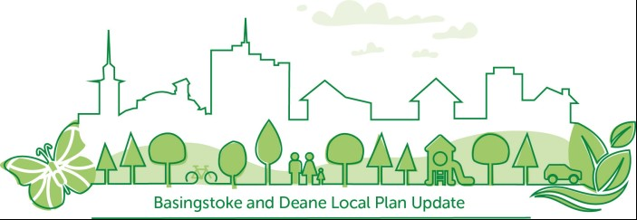

Local Plan Update: Issues and Options Consultation
Representation Form

The Basingstoke and Deane Issues and Options Consultation is currently open for comment for a period of 6 weeks from Monday 28th September to 4pm on Monday 9 November 2020. For advice on how to response to the consultation and to see the consultation documents please visit the council’s website at: www.basingstoke.gov.uk/Issues-and-Options

The council are also seeking information on additional Local Green Spaces, please see the Local Green Space Promotion Form and guidance note to submit sites, which is available to view on the council’s website: www.basingstoke.gov.uk/Issues-and-Options

If you would like any of the Issues and Options Consultation information, including this form in a different format, e.g. large print, Braille, please contact customerservice@basingstoke.gov.uk or call the council’s Contact Centre on 01256 844844.

Representations made via this form should relate to the Issues and Options consultation document only. The council are also inviting comments on a number of supporting documents and these can be made via email to local.plan@basingstoke.gov.uk or in writing to Planning Policy Team, Civic Offices, London Road, Basingstoke, RG21 4AH.

Representations should be submitted by 4pm on Monday 9 November 2020.

Representations can be submitted either by completing an online form at https://basingstoke-consult.objective.co.uk/portal

Or by returning this form to Basingstoke and Deane Borough Council:
by post to: Planning Policy Team, Civic Offices, London Road, Basingstoke, RG21 4AH
by email to: local.plan@basingstoke.gov.uk

For further information on the BDBC Local Plan Update please see: www.basingstoke.gov.uk/lpu

If you have any queries or issues whilst completing the form, please either email local.plan@basingstoke.gov.uk or call the council’s Contact Centre on 01256 844844.

Local Plan Update: Issues and Options Consultation Representation Form

This form has two parts:
Part A – Personal details
Part B – Your representation(s) on the Local Plan Update: Issues and Options Consultation– please fill in a separate form for each representation you wish to make.

Part A – Personal details
Title: | Name:
Organisation:  (where relevant) | Job title:  (where relevant):
If you are an agent, who are you representing?

Address:  Postcode: | Email address:  Telephone number:
Preferred method of contact: | Email Post
Are you responding as:
An individual A town or parish council
A district/borough council A borough councillor/MP
On behalf of an organisation On behalf of a community group
A landowner/developer/agent/architect Other

PART B – Representations on the Issues and Options Consultation

Please fill in a new Part B form for each representation on the Issues and Options Consultation, please do not include any personal details in this section of the form.

- Please state which question(s) or aspect of the Issues and Options Consultation you are commenting on:

Question number (s):
Other (please quote relevant chapter, table or paragraph):

- Please provide any comments below:

Continue on a separate sheet if necessary

Next Steps

Thank you for your comments. The borough council will review all of the comments received during the consultation and will make these available on the borough council’s website. Please be aware that comments received cannot be treated as confidential.

Representations on the Issues and Options Consultation may be withdrawn at any time by giving notice in writing to the borough council’s Planning Policy Team.

Local Plan consultation database

If you wish to join the council’s planning policy database to receive notifications on future planning policy consultations, events and newsletters regarding the Local Plan Update, please tick the box

Data Protection Statement

Basingstoke and Deane Borough Council is the data controller for the personal information you provide on this form. You can contact the council by phone on 01256 844844, via email to customer.service@basingstoke.gov.uk or by writing to us at Civic Offices, London Road, Basingstoke RG21 4AH. The council’s Data Protection Officer can be contacted at dpo@basingstoke.gov.uk
In complying with the General Data Protection Regulation (GDPR), Basingstoke and Deane Borough Council confirms that it will process personal data gathered from this form only for the purposes relating to the consultation. It is intended to publish responses to the Issues and Options consultation on the council’s website. This will include publication of names of respondents and company names (where appropriate). Please ensure you do not include any personal information in Part B of the document. Copies of all consultation responses, including Part A, will be available to view at the council offices, and photocopies can be made of these representations on request.
- we will not disclose any information to other organisations unless we are required by law to do so
- your personal details will only be held as long as is needed for this consultation and in accordance with our retention policy.

As a public authority the council is subject to the provisions of the Freedom of Information Act (FOIA) and Environmental Information Regulations (EIR). This means we may be required to disclose information provided as part of this consultation if it is requested. Personal data will not be disclosed under FOIA or EIR.

For further details on how your information is used; how we maintain the security of your information and your rights, including how to access information we hold on you and how to complain if you have any concerns about how your personal details are processed, please visit www.basingstoke.gov.uk or email dpo@basingstoke.gov.uk.

